Name:
PARCC Practice: Please answer the open response questions in complete sentences. You will get the information for your answers from the two articles. Make sure that you restate where appropriate. You do not have to mark the questions for this assessment. You must use complete sentences to answer the open response questions.
1A What does the word “foe” mean in paragraph of the Federer article?
- Friend
- Enemy
- Acquaintance
- Teammate
1B What word in paragraph tells us that this is what it means?
- lousy
- prominently
- contend
- earned
2A What does the word “culminating” mean in line 7 of paragraph 2 of the Nadal article?
- To be at the beginning of something
- To be at the end or final result of something
- To be in the middle of something
- None of the above
2B What quote in paragraph 2 tells us that this is what it means?
- “ In late 2004, Nadal upset Andy Roddick in the Davis Cup final, helping Spain to the title.”
- “Rafael Nadal played and won his first pro match in 2001 at the age of fifteen.”
- “He would reach the number two ranking later that summer.”
- None of the above
3. What is the author’s purpose?
a. To evoke sadness
b. To entertain
c. To give information
d. To give a biased opinion
3. What are three reasons why Roger Federer is the greatest of all time?

4. What are three reasons why Rafael Nadal is the greatest of all time?

5. Who do you think is the greatest, based on the article? Make sure to use evidence to support your opinion.

6. Based on information in the article, compare and contrast Roger Federer and Rafael Nadal.
Create a Venn Diagram
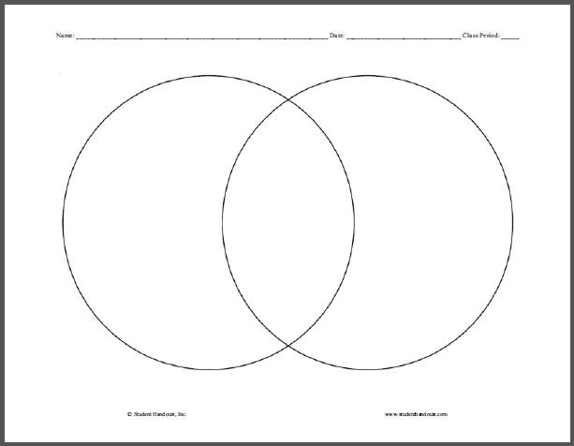
Now write a brief paragraph based on the Venn diagram.
______________________________________________________________________________
______________________________________________________________________________
______________________________________________________________________________
______________________________________________________________________________
______________________________________________________________________________
______________________________________________________________________________
______________________________________________________________________________
______________________________________________________________________________

