Nematodes Peer Instruction Answer Key
- Compare and Describe Ingestion and Digestion for the four phyla listed below:
 | Sponges (Porifera) | Cnidarians | Flatworms (Platyhelminthes) | Roundworms  (Nematodes)
Ingestion | Sponges are suspension/filter feeders meaning they collect food particles from water with food trapping equipment. To trap food sponges are able to sweep water through their body with the whip-like flagella at the end of the choanocyte cells. As the water (with bits of food) is drawn in through the outer pores of the sponge it rushes toward the central opening. Just before the water exits the central opening there are cells called choanocytes. These cells look like this  The cone shaped part is covered with mucus that is sticky. As the water (with bits of food) rushes by the mucus “collar” of the choanocyte the food sticks to the mucus and the water keeps moving. | Cnidarians have muscles and nerves. The nerves in the tentacles sense the prey. The muscles are triggered by the nerves so the prey can brought to the mouth and ingested. | Planarians ingest food through mid-ventral muscular feeding tube.  Flukes (not included in packet)  Tapeworms As adults, they live in the small intestine of vertebrates bathed in the food that was eaten by their host. They do not have a mouth or gastrovascular cavity. The food passes through their skin. The science way to say that is the food diffuses through the surface of tapeworm. | Nematodes have a complete digestive track with and opening and an exit. Food is ingested through the mouth.
Digestion | The food is then engulfed and put into a little food package. Another type of cell called an amoebocyte picks up the food and digests it. Amoebocytes can move around. This makes sense as they have to pick up the food from the choanocyte. Once they pick up the food, they can break it down into small pieces and digest it (think of this like our stomach with the chemical digestion). Now the nutritious remains of the food are carried around by the amoebocytes to the other cells in the sponge. | The mouth leads to the gastrovascular cavity. May have a jelly-filled middle layer between the outer skin and the lining of the gastrovascular cavity that has scattered amoeboid cells. The gastrovascular cavity moves the nutrients around to the tissues of the cnidarian. | Planarians have one entrance to their gastrovascular cavity (GVC). Because the GVC is highly branched the food inside is close enough that it can reach all tissues to supply the planarian with nutrients.  Flukes Didn’t specify in packet.  Tapeworms Because the food is passing through the skin of the tape worm equally on all sides, all tissue receives the nutrients needed passively. | Once food is ingested through the mouth, it travels toward the anus. (It is important to note that the food is going in one direction for the FIRST time in the animal kingdom!) Because the food is only going one direction, each part of the digestive tract can begin to become specialized (meaning they can do different jobs)  Anterior End churns and mixes the food with enzymes and the Posterior End Absorbs nutrients and disposes of waste.  Pseudocoelom distributes nutrients throughout the body

- What is C. elegans and how has it helped humans?
Caenorhabditis elegans is one species of nematode that humans have studied very closely. This worm is not very large and only has 1,000 cells as an adult. Scientists decided that they would track each cell in C. elegans from when the nematode was “born” to when it was a fully grown adult. By understanding how these cells develop over the nematodes life humans benefit in three ways:
- Helps us understand how genes control animal development
- Helps us understand how the nervous system works
- Helps us understand how humans age.

3) Pseudocoelom
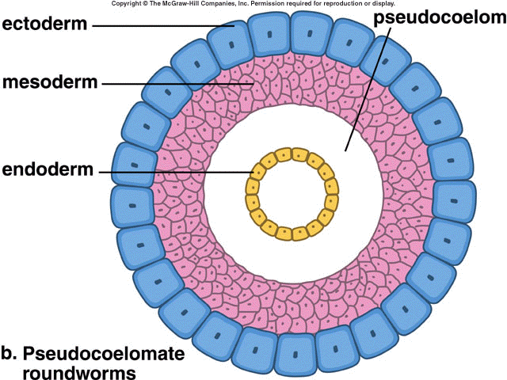
*Distributes nutrients throughout the body
* Functions as a hydroskeleton

Complete Digestive Tract:
- The benefit of a complete digestive tract is that each portion of the digestive tract only needs to serve one job. When there is only one opening to the gastrovascular cavity each section has to perform more than one job. For example, the mouth of a nematode with a complete digestive tract only serves the purpose of mouth, where the mouth of a jellyfish serves the purpose of mouth and anus. You may notice that in the complete digestive tract of the nematode there is a front portion (anterior) with the job of churning and mixing the food with enzymes and a end portion (posterior) with the job of nutrient absorption and eliminating waste. The science way of saying this is, the cells in the digestive tract are specialized with different structures that fit their function.
Why the body plan doesn’t vary:
Body plans remain the same over millions of years across a group of animals when the body plan is successful. Here is another example of a successful body plan that hasn’t changed much. This picture is a turtle named proganoclese that walked the earth with the dinosaurs. Turtles still look like that!! It is because the body plan is successful. They don’t die out. That is how it is with nematodes. They are so successful they are found in all environments from bottom of the ocean to the tops of cold mountains.
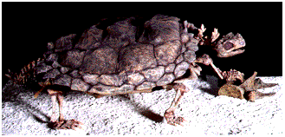

Cuticle
This is tough material that helps protect the outside of nematodes. It is not alive! It can protect the worm from the strong digestive juices in the stomach of a host. Because the cuticle is thick and tough the water/moisture inside of the nematode doesn’t evaporate out of the worm. In other words, the cuticle prevents the nematode from drying out. This is like how lotion prevents your hands from drying out. As the nematode grows, the cuticle doesn’t grow along with it. When the nematode sheds its cuticle, it leaves behind the outer shell and secretes a new cuticle to protect its larger body. This is like how a snake sheds its skin.

- What’s the difference between parasitic roundworms and parasitic flatworms?

Parasitic Flatworms:
There are two types: flukes and tapeworms:

Flukes: have a complex life cycle with an intermediate host, and then infect the final host.

Adult tapeworms: live in the digestive tract of vertebrates. Tapeworms usually have more than one host. Most benefit from the predator- prey relationships of their host meaning that it takes advantage of something that already exists. The anterior (front) end has hooks and suckers that attach to the host. Although the tapeworms live in a digestive tract, they don’t have one! This is a rule breaker in terms of the animal kingdom.

Parasitic Roundworms:
They can live in the moist tissue of plants (that is different than tapeworms!) body fluid or the tissues of animals. They are serious agricultural pests that attack the roots of the plant or parasitize animals. It is spread by mosquitoes which get the larvae from the blood of an animal and when it goes to suck the blood of another it is transferred. You also might find these in dog hearts, where they are common.

