CHAPTERS 6-10

N E:

Date: Period: _

CHARACTERIZATION: COMPARE & CON1RAST
How do Eric and Four contrast one another? How are they similar? Give evidence from the novel that reveal
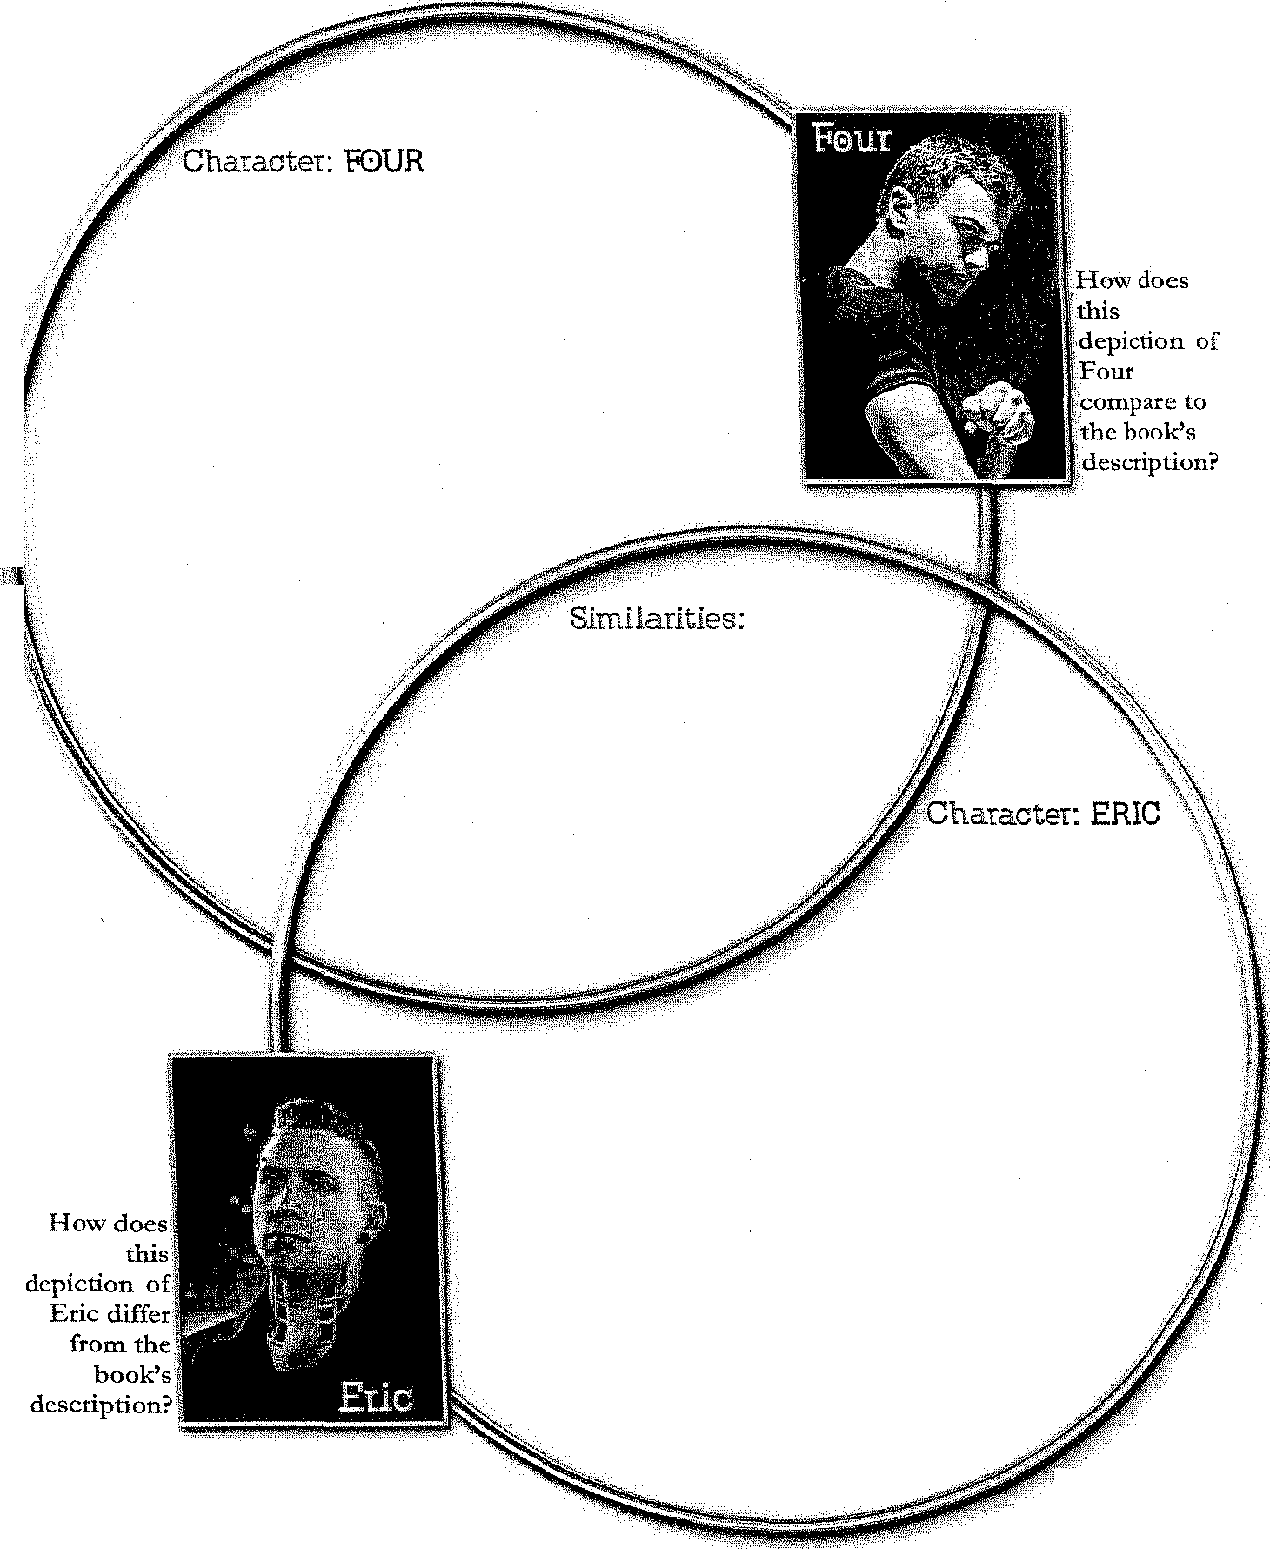
their similarities and differences.

·:·1

STANDARD: CCSS.F.1,r\"\,il\'rac'".CCR.'\.R3
29
]mages courtesy of SVMiviiT fiNTB.'RTAINMENT@ Copycight © 2014, Tqyer Orm'O

Chapters 6-10 LANGUAGE DEVICES: VERBAL IRONY
Verbal irony refers to the use of vocabulary to describe something in a way that is other than it
seems. Often, but not always, verbal irony is used with a sarcastic tone. Verbal irony is often a comment that conveys a different meaning than what it may seem to be.

1. How does Tris use verbal irony on page 66? -------------------

2. Why do you think Tris uses sarcasm in this situation? What effect does it have? _

3. Note other instances where Tris uses verbal irony. What purpose does it serve for her? _

I
I -------------------------------------------------------
i· I
,1------------------------------------

28 STANDARDS: CCSS.ELA-J.jteocy.CCR/\JCJ, CCSSJ:1.l./>.A.,irccu::y.U.Jt/\,RA Copyright '1:! 2014, Dyre Qrmm

